# Study Buddy - User Manual

1. **Creating an account**
   1. **Click on Sign In / Sign Up on the landing page:**

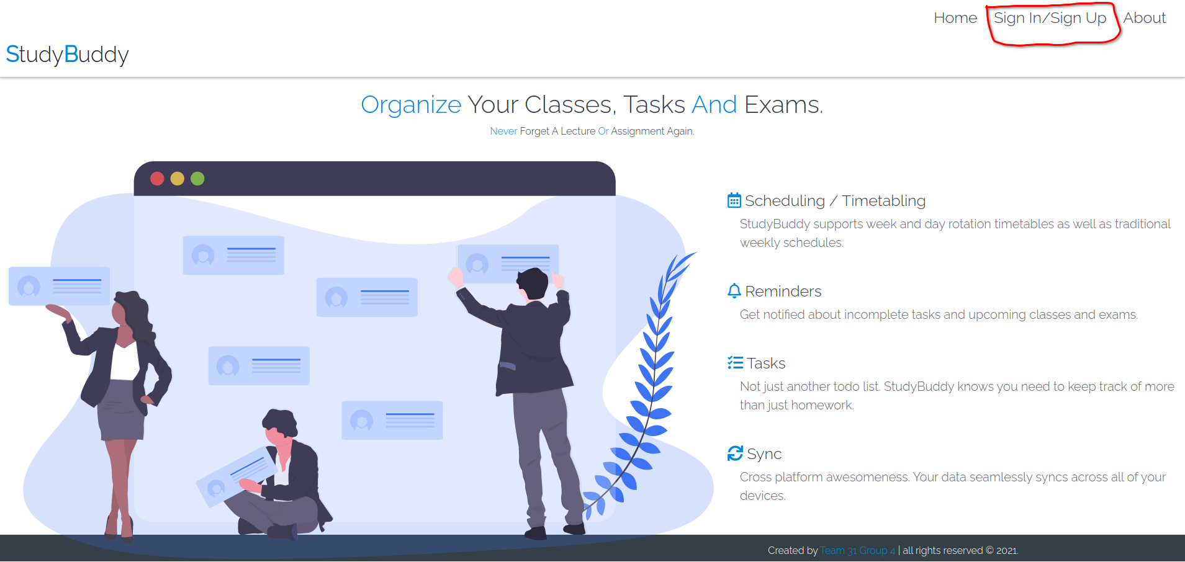

* 1. **Fill out username, password and email address**

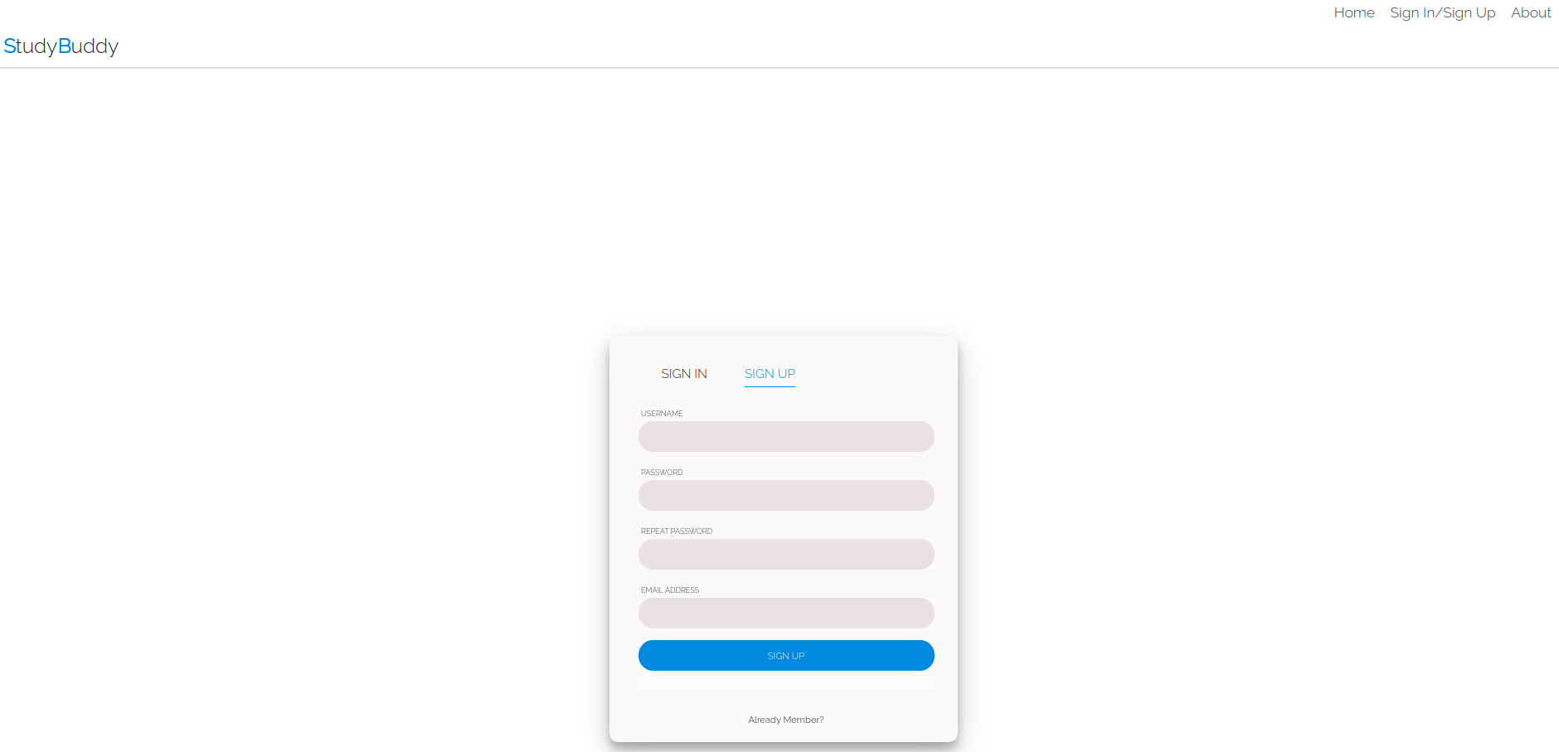

* 1. **Verify your email address by clicking the link in the email received**

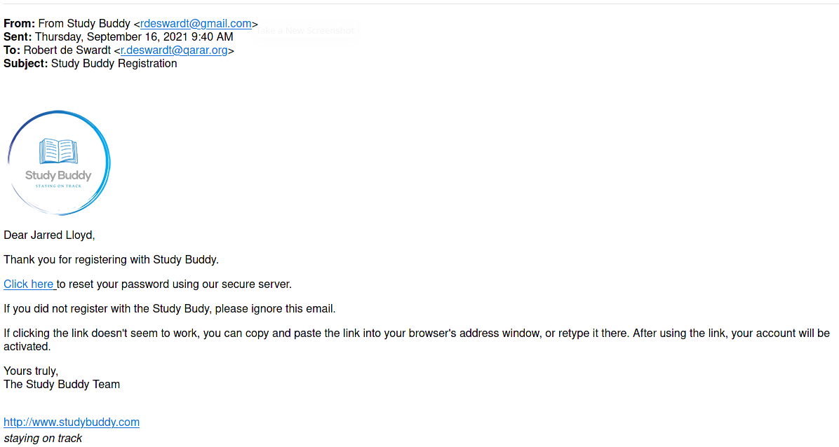

* 1. **Log in to your account**

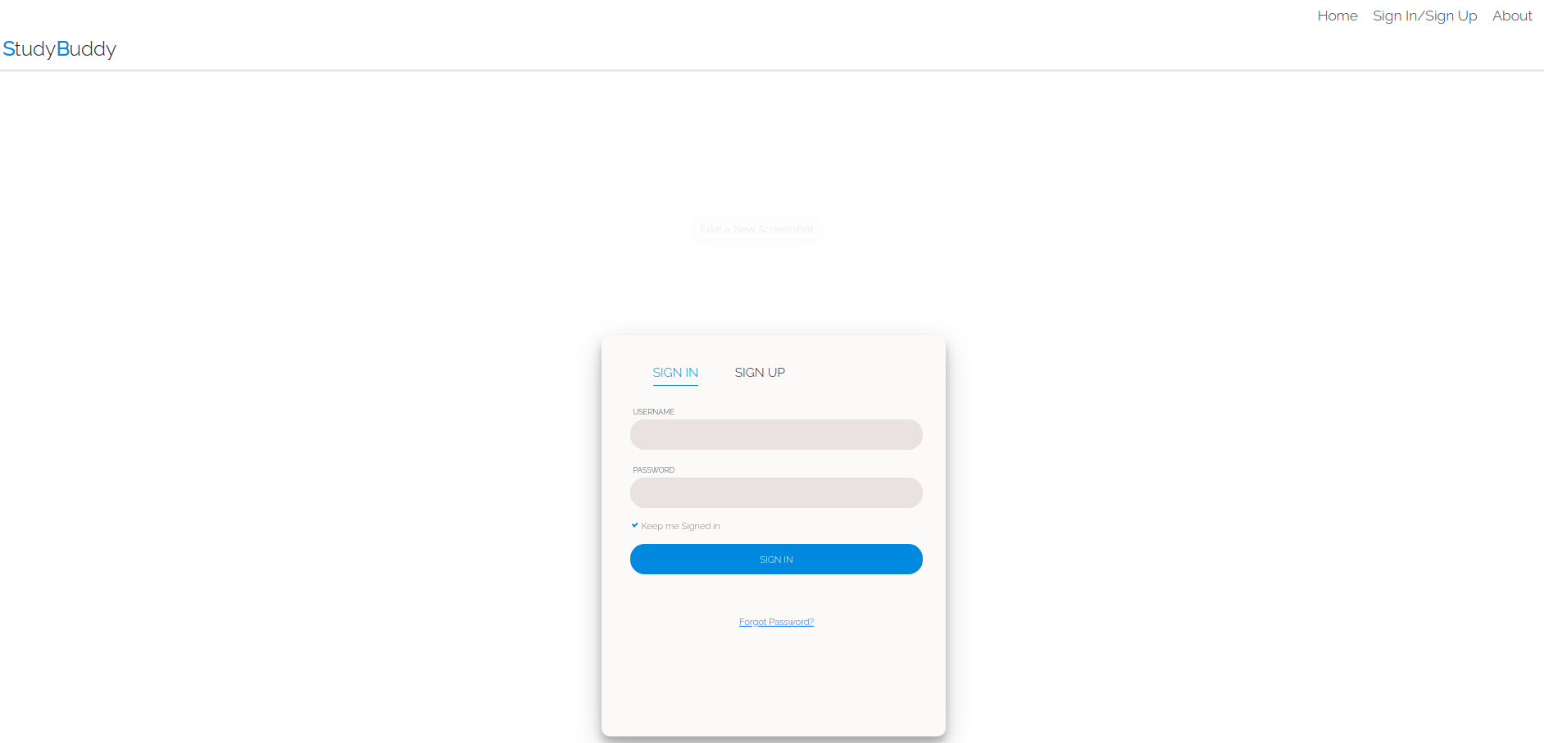

1. **Overview, Tasks and Modules**
   1. **Add / Remove new modules and tasks**

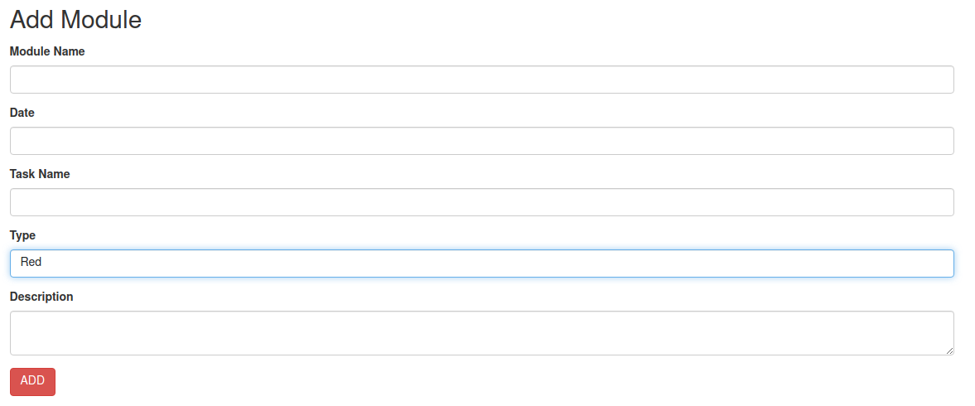

* 1. **Visualise your progress by using the checkboxes.**

